**Lab 2 Report**



Session: 2022 – 2026

**Submitted by:**

Name: Robass Atif

Registration No: 2022-CS-150

**Submitted to:**

Mr. Numan Shafi

Department of Computer Science

**University of Engineering and Technology**

**Lahore Pakistan**

**VMware workstation**

## First is to open <https://www.vmware.com/in/products/workstation-player/workstation-player-evaluation.html> that link and click on download button.

## 

1. After complete download open it and click on next Button.

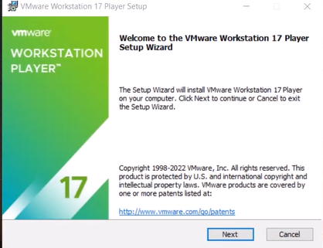

1. Now fill the check box and click on next button.

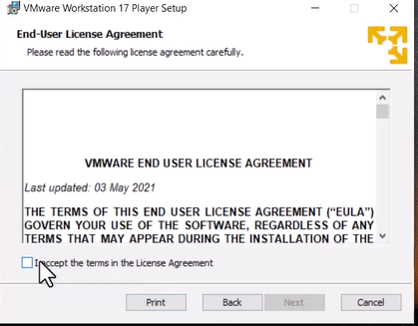

1. After that click on next button.

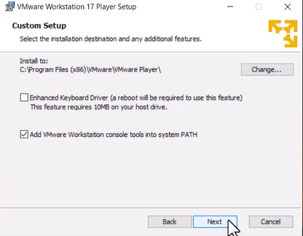

1. After that again click on next button.

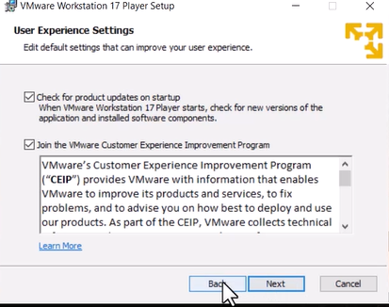

1. Again click on next.

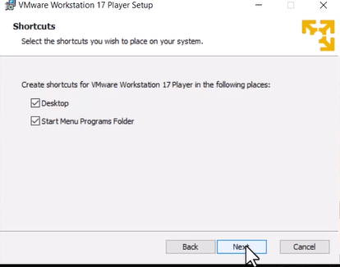

1. Then click on install button

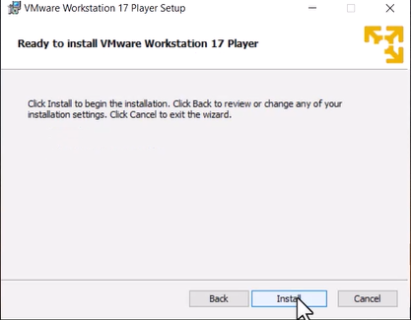

1. Finally, finish it.

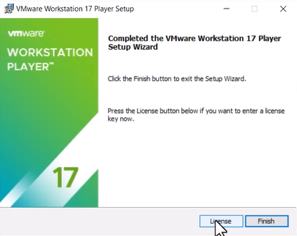

**Window Installation**

1. First of all go to that link

<https://www.techworm.net/2022/08/download-windows-10-iso.html>

and click on download button.

## 

1. After complete downloading extract the .zip file.

